RECORDING MASTER NATURALIST VOLUNTEER HOURS

Recording volunteer hours is very easy. Hopefully this tutorial will help. Don’t be overly stressed about it, just record what feels right according to the guideline defined at this link: http://www.clemson.edu/public/naturalist/pdf/volunteer_definitions_requirements.pdf

Any questions you have may be addressed to:
Midlandsmasternaturalist@gmail.com or
Dee Dee Williams at cwilliams64@sc.rr.com

Step by step instructions:
Go to Clemson MN website:

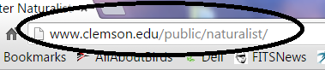

Look for “Volunteering” option on left of page. Select it.

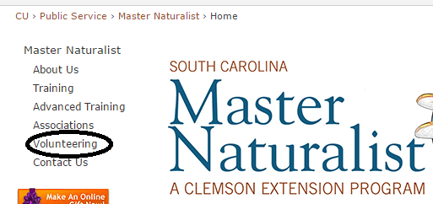
On page right, select “Online Volunteer Hour Reporting System”
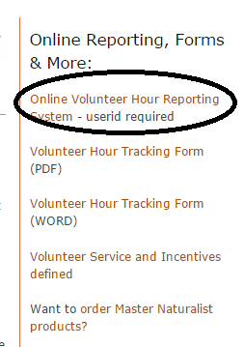

Your initial User ID and Password is included with the graduation packet you received. After initial logon, you may change it.
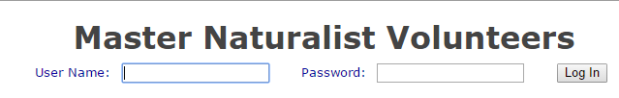

The “Volunteer Database” page is accessed. Here you can record hours, run reports, change password or account info. Ignore all the line option questions beginning with “I am” – not necessary. Choose Record Hours to enter info.
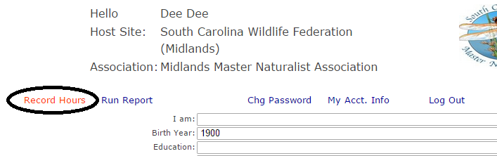

On next page, click on “Add New Record”
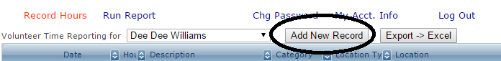

Choose volunteer category; there is a description for each one. I entered a sample record. Category - “Citizen Science” – note description on right. Next: Location Type. Once type is chosen, a list of those locations will be displayed when you click on “Location Description”. Select date, and enter number of hours. If your location is not included in the drop lists, you may choose “other” and fill in free form. VERY IMPORTAN T!!! This catches a lot of folks…. You must click “Save Changes” after each record. If you enter multiple records, and only click save on the last one, only the last one will be saved, and you will need to re-enter the others.

